|  |  |
| --- | --- |
| Key Vocabulary and Facts | |
| Life-cycle | A series of stages through which something passes during its lifetime |
| Senses | We have five basic human senses: touch, sight, hearing, smell and taste |
| Beanstalk | The stem of a bean plant |
| Germination | The development of a plant from seed to spore |
| Kenya | Is a country in Africa |
| Adjective | A word used to describe and give more information about a noun, which could be a person, place or object. |

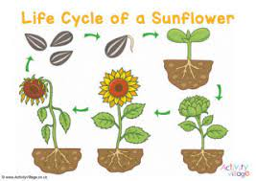

Key Questions and Lesson Foci:

Can I use my senses to explore changes outside and identify signs of spring?

Can I explain what a plant needs to grow and explore plant growth?

Can I recall the main events from our class stories and adapt my own?

Can I explain the life cycle of a sunflower and why the cycle is continuous?

Can I compare fruit grown in this country with fruit grown in Kenya?

Growing

Learning about growing – involves guiding children to make sense of their physical world. Children will be able to... observe changes in the season of spring. They will develop a sense of empathy towards nature and how to protect it. They will notice the growth and change of plants and the importance of caring for living things and their responsibility for taking care of the planet. Learning about growing inspires children to be ‘emergent biologists’ by developing their natural inquisitiveness and curiosity about their living world.

**Our Wider World!**

Retrieval – What should I already know? There are different seasons throughout the year. During these seasons the natural environment changes such as trees and plants, along with the weather.

**F2 LEARNING – KNOWLEDGE ORGANISER**