**Langtree Community School**

**Can you? Ideas to support your child’s learning at home**

* Can you draw the life cycle of your favourite mini-beast?
* Make a book about caring for mini-beasts.
* Make a mini-beast home.
* Go into a garden/ field and find as many worms as you can.
* Which colours of ladybird can you see?
* Practice number bonds using the spots on both sides of a lady bird’s back.
* Go on a bug hunt: how many legs does each mini-beast have?
* Make a bug mask.
* Make a picture with as many people and mini-beasts as you can, living happily together!
* Make up a sea shanty.
* Find out the names of our seas/oceans. Have you swum in any of these?
* Investigate why seas/oceans are so important to communities.
* Go paddling in the sea with an adult: how strong is the tide?
* Investigate how sails help a boat.
* Look at reflections in water, what can you see?
* Look at living things which are in our seas/oceans, what amazing facts can you find out to ‘wow’ your class mates?
* When you get in the bath, what happens to the water level? Why?
* How many toys can you put in a toy boat in the bath before it sinks?
* Can you make a floating object sink or an object that sinks float? What strategies and scientific thinking did you use?

ICT – Websites you can share with your child to support learning at home

http://www.bbc.co.uk/cbeebies/something-special/stories/something-special-mrtumbleandtheminibeasts/

http://www.mylearning.org/minibeasts/

http://www.ypte.org.uk/animal/minibeasts/30

http://www.doeni.gov.uk/niea/minibeast_for_web.pdf

http://highlandschools-virtualib.org.uk/primary_curriculum/minibeasts.htm

***Learning Journals***

Your child has their own learning journal on Tapestry, and we would invite parents/carers to share in their child's learning. We welcome you talking with your child about the observations that have been made, and taking family pictures or other things of significance for your child to add to this. We value that your child is unique, and along with our observations, any information you provide will help inform our planning to give them the best environment to learn.

**Don’t forget to post observations to Tapestry for any ‘WOW’ moments in your child’s learning!**

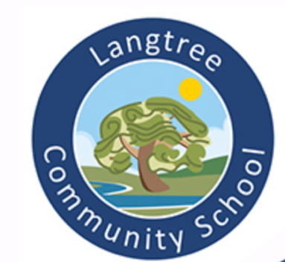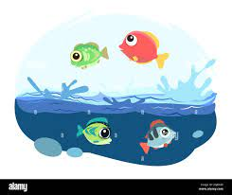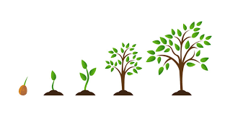

**The Sea**

**Growing**

**Our Learning—Summer 2024**

A booklet to enable the partnership between parents, carers and staff at Langtree Community School

To develop the Learning of our children.

*Dear Parents and Carers,*

*Our planning is flexible and allows us to take account of your child’s developing interests therefore we may add activities and themes to what is written here. We may also have a focus on a curriculum area e.g. Maths, Phonics rather than a topic or theme. Our planning relates to building the skills for lifelong learning and challenges that meet characteristics of effective learning.*

Miss Batstone and Mrs Symons J

**Physical Development** We continue to use leap into life, squiggle while you wiggle and dough disco to develop crucial physical skills from the ‘Early Years Curriculum, and aim to develop the children’s confidence in moving in different ways (both fine and gross motor) with an awareness of space and others. During our term we will be looking at developing of these skills.

**Communication and Language** We will be increasing the quantity and detail of information that the children listen to, in order to extend their attention and comprehension. We will also be encouraging children to develop their own stories and explanations, connecting ideas and events. We will be further developing the use of questioning skills relating to sea creatures and the world’s oceans and seas and our ability to answer how and why questions. We will give the children opportunities to express themselves encouraging their use of details, showing awareness of the listener’s needs.

**Personal, Social and Emotional Development** We will be thinking about the feelings of others including the feelings of other living creatures. We will be using different opportunities to develop the confidence to speak in front of others. We will be working collaboratively with others during activities such as dance and art. We are aiming to develop a sustained period of involvement and perseverance, in individual and group work and the confidence to communicate thinking. Alongside this we will be practising showing respect for the ideas and thoughts of others as well as the skills needed to solve minor disagreements ourselves and see things from someone else’s point of view.

**Understanding the World** We will be learning about life cycles of sunflowers. There will be opportunities to observe and talk about similarities and differences in living things and the world around them such as comparisons between fruit grown in the UK and Kenya. We will be making observations and learning about various sea creatures. We will also be aiming to develop knowledge of the world’s land and water and how this affects people’s lives. The children will continue to use ICT as a learning tool in a variety of situations.

**Mathematics** We will begin to focus on our teen numbers to 20, and their composition before beginning to investigate patterns in number such as odds, evens, halving, doubling and bonds to 10. We will be practising adding and subtracting through role play and thinking about ideas, strategies and functions needed to solve mathematical problems. We will continue to consolidate our understanding of 2D and 3D shapes, including their properties, and use everyday language to talk about time and money to compare quantities and solve problems and sequence events.

**Literacy** We are aiming to develop an understanding of non-fiction texts as a way of finding out answers to who, what, when, where, why and how questions. We will also be thinking about how we can learn about different animals from stories. This will be achieved through researching questions, visits to our library, use of the internet, writing and reading. We will develop the children’s skills to write for a variety of purposes, e.g. fact sheet, lists, instructions and adapting known fairy tales by planning and recording our ideas independently. We continue to develop a range of reading strategies.

***Our Values:***

Respect

Kindness

Honesty

Responsibility

Key events:

*Eid*

*Story telling month*

*Walk to school week*

*National Bee day.*

**Expressive arts and design** We are aiming to develop skills in combining different materials and textiles through collage looking at the work of Eric Carle. We will have many

opportunities to sing together and perform. They will be given represent their own ideas, thoughts and feelings through design and technology, art, music, dance, role play and stories

**SPECIFIC AREAS**

**PRIME AREAS**