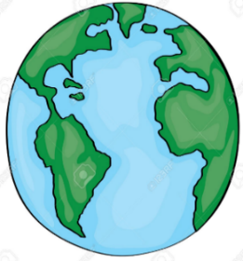 | -Our world is a planet called Earth. It is one of a number of planets that go around the Sun.  -This system of the Sun and planets is called the Solar System.
Key Vocabulary and Facts
Sun | A huge star that Earth and the other planets in our solar system orbit around.
Moon | A rock that orbits Earth/ other planets.
Crater | A hole in the ground caused by an explosion or the impact.
Asteroid | Asteroids are like mini planets that are made of material like rock.
Planet | A ‘sphere’ object that orbits a star.
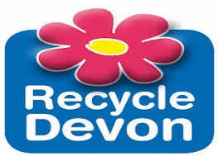
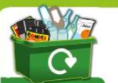
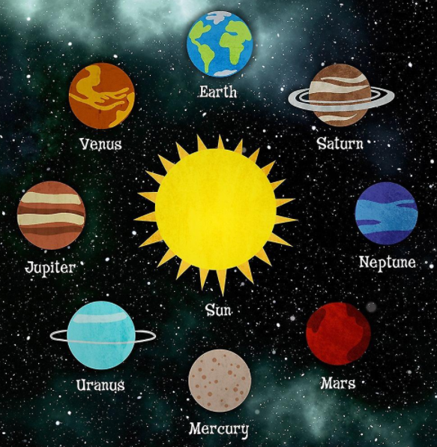
In Science, we look at the world around us. Scientists try to find out how and why things happen.
- Scientists learn about their subject by observing (looking at things) and experimenting (testing things).
Early Science learning is found in the following EYFS areas of learning:
-Understanding the World
-Expressive Arts and Design
-Physical Development

Key Questions:
Can I tell you on which planet I live and features of my immediate environment?
Can I share some facts about the different planets? (For example, Mars is red and rocky)
Can I explore what a star is and a constellation?
Can I investigate what a crater is and how it is made?
Can I explore what an ‘Alien’ is and create my own?

Help your child by teaching them the importance of looking after their planet.
Help them to realise how fragile our own planet is and the message of the importance of looking after planet Earth. Whether it be through recycling, protecting our wildlife or reducing pollution- children can start from an early age to contribute to making a difference; establishing it as an integral part of their lifestyle.

Learning about space –Sparks Imagination and Ignites Curiosity– It is all about the unknown, the 'what ifs?’ and the fascinating questions. It helps children become creative thinkers, to challenge current theories and to question. Aiming High– Learning about space is about inspiring the next generation of astronomers, and helping them to have high expectations of themselves and of their futures.
SPACE
The 8 Planets in our solar system
F2 LEARNING – KNOWLEDGE ORGANISER

