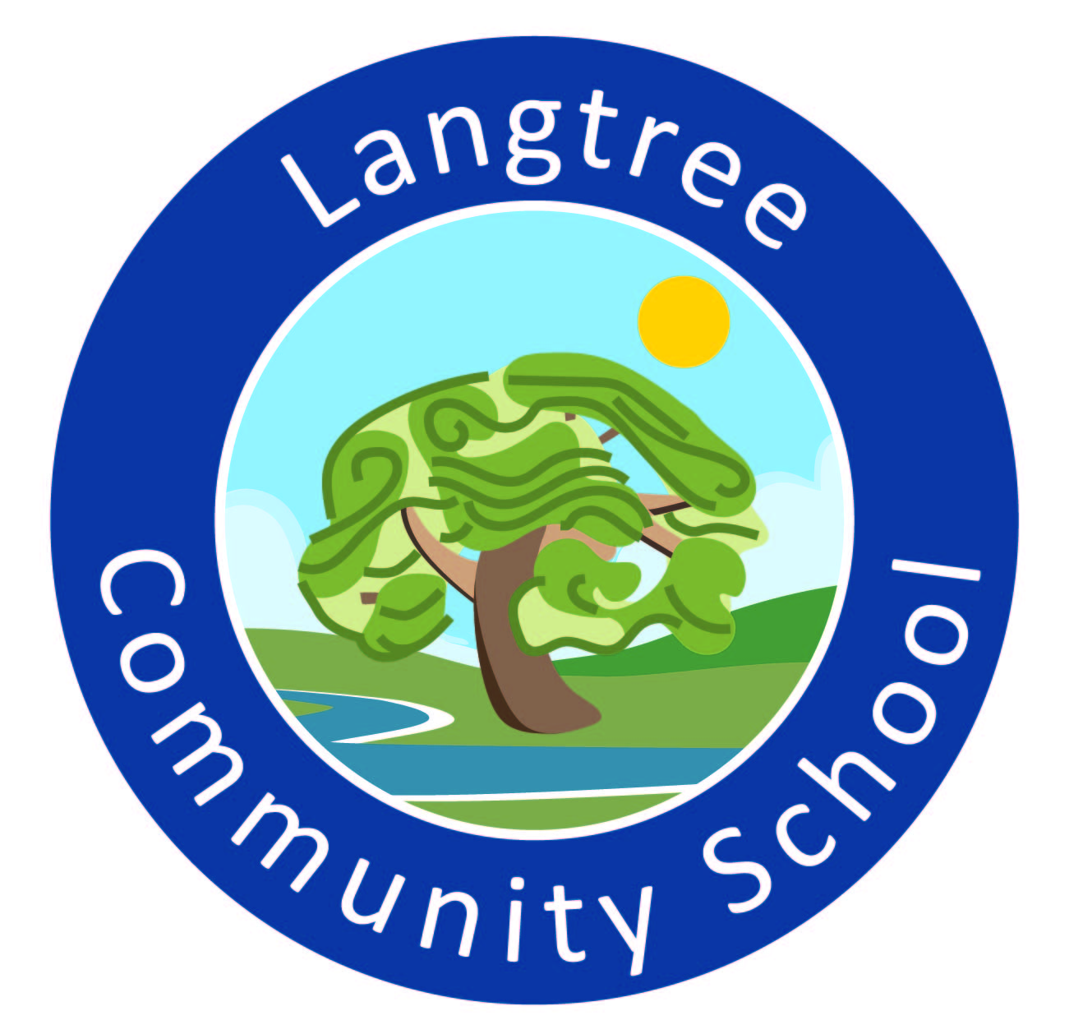

Langtree Community School and Nursery
Person specification: Teaching Assistant

 | Essential | Desirable
Qualification | GCSE qualification in literacy & numeracy. | Previous training: (please identify in your application).
Experience | Worked with all children, including SEN: Primary age range, either school or voluntary worker or parent. | Supported or worked with KS1/2 SEN children.
Knowledge & understanding | How children develop emotionally, socially and academically.  How to support all children with their unique learning styles.  How to motivate pupils to complete tasks and make progress. | Knowledge & understanding of strategies used to support pupils with learning difficulties.  Knowledge and understanding of the Thrive approach and relational practice.
Skills | Support an individual pupil within a whole class setting or a small group within mainstream school.  Work closely with teacher/TA and other agencies in order to support the learning needs of an individual.  Manage children’s behaviour in a positive manner.  Good organisational skills.  Ability to think on your feet.  Make teaching resources.  Encourage and develop communication and pupils social skills.  Use initiative within ethos of the team. | Monitor, make assessments & record targets on individual pupils.  Work within a team to assess and develop skills, set targets and create opportunities for all pupils to make progress.  Differentiate tasks set by class teachers making goals clear and achievable.  Be able to think outside the box.  Willingness to undertake activities necessary in pupil’s development of social skills  Good ICT skills. Ability to use ICT to enhance learning.
Personal characteristics | An ability to work positively with families. Calmness, enthusiasm, initiative, flexibility, positive nature, empathy, confidentiality. | Have a sense of humour.

