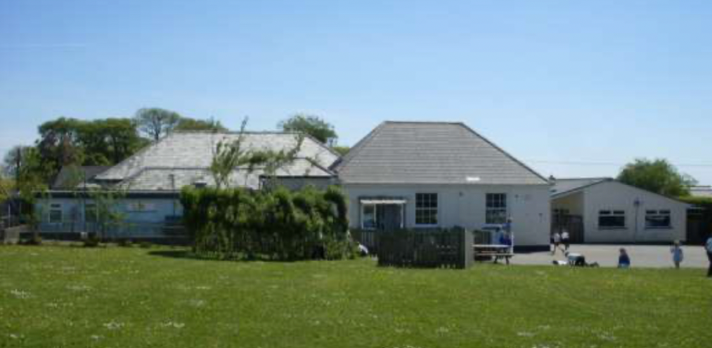

**Langtree Community School**

**Can you? Ideas to support your child’s**

**learning at home**

* What do you notice is growing in the garden or the park? Can you sketch what you see?
* When shopping what fruit and vegetables do you buy?
* Do you notice the leaves on the trees changing? How have they changed? Can you paint the changes?
* Can you find or make up your own harvest recipe? Which ingredients will you use? How do they change when you cook them?
* Can you remember any names of people who help us in school?
* Can you make a thank you card to give to someone who has helped you?
* Draw your home with pictures of the people who help you.
* Make a fireman’s hose, a police officer’s walkie talkie or a doctor’s kit.
* Make your own emergency vehicle, with flashing blue light.
* Bandage up a teddy and write down your ‘doctor notes’.
* Keep a diary of the food you eat for a few days. Put a circle around the healthy food.
* Make a poster to encourage your class to brush their teeth regularly.
* Make an appointment book that has times and dates to use in your role play.
* Remember to read as often as you can. Talk about the reading strategies you use.

**Learning Journeys**

Your child has their own learning journey book, and we would invite parents/carers to share in their child's learning. We welcome you talking with your child about the book, sticking in family photographs or other things of significance for your child. We value that your child is unique, and will be sending a letter home to gather any current information on their interests and news that, along with our observations, will inform our planning to give them the best environment to learn.

**Don’t forget to post observations to Tapestry for any ‘WOW’ moments in your child’s learning!**

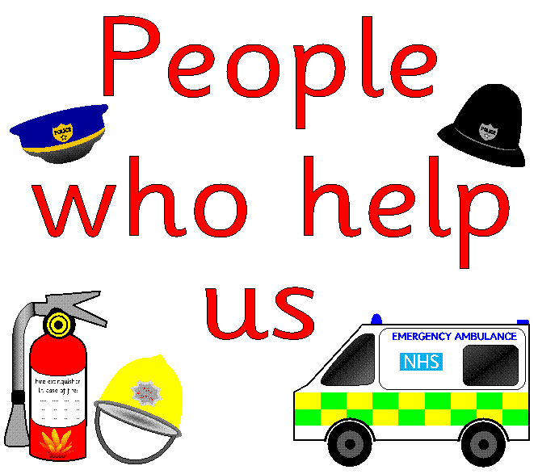

**Our Learning—Autumn 2023**

A booklet to enable the partnership between parents, carers, and staff at Langtree Community School

**All about me**

To develop the learning of our children.

**Mathematics** We will be thinking about how numbers are used and are aiming to develop the skill of saying number names in order and recognising numerals. This will be achieved through songs and rhymes. We will be talking about the role of maths in our everyday lives and how we solve problems using mathematical ideas. We will be investigating numbers to 10 in depth and the connection between these numbers. Through activities such as cooking we will explore measurement and discuss different ‘quantities’.

*Dear Parents and Carers, Our planning is flexible and allows us to take account of your child’s developing interests. Please can you remember a to send you children in with P.E kits for Thursday afternoons. This is our new P.E session time. Reminder – as a healthy school, we encourage water as a preferred drink in your child’s bottle. WOW observations on Tapestry are very welcome and watch out for parent information sessions on Phonics and Early Maths.*

*Miss Batstone and Miss Symmonds.*

**Physical Development** We use dough disco, squiggle while you wiggle, pen disco, rainbow writing, and ‘big P.E’ sessions to develop crucial physical skills from the ‘Early Years Curriculum, and aim to develop the children’s confidence in moving in different ways and an awareness of space and others. We will also be developing some pre-writing skills such as strength and fine motor skills. This will be achieved through opportunities to use large and small apparatus, digging, dancing, climbing, mark-making using a variety of resources. We will also be thinking about how to keep fit and healthy.

**Our values:**

Respect

Kindness

Honesty

Responsibility

**Festivals:**

***SUKKOT***

***HARVEST FESTIVAL***

***BONFIRE NIGHT***

***CHRISTMAS***

**Understanding the World** We will think about our customs for Christmas and look at how Harvest is celebrated in different faiths. We will look at how a seed becomes a loaf of bread and the importance of farming in our community. We will also be thinking about technology in our lives and how we use it and assisting the children to develop an idea of how different services in the community work together to keep us safe and healthy. We will also explore why we have a poppy appeal, and bonfire night.

**Expressive arts and design** The children will be encouraged to respond using a variety of art forms to show their feelings. They will be given the opportunity to experiment with various media, equipment and instruments through the celebrations of Christmas and Harvest.

**Personal, Social and Emotional Development**

Apart from our planned time together for sharing stories, circle times and Show and Tell, we will be focusing this term on ‘making relationships’. We are aiming to develop the levels of involvement in activities and the ability to build relationships with others. We will be talking about class and school rules and how to make sure that we take turns. We will be making class book about the big questions in our lives and thinking ‘About me’ and what is special about us.

**Literacy** We will read and share a variety of texts related to our themes and use basic ‘story mapping’ to remember them. We will have lots of mark-making opportunities through our environment and will practice developing our muscles for holding our pens and pencils for writing. We are aiming to develop a love of reading and will also support this through guided reading sessions during ‘Reading Carousel’. In phonics we will be learning sounds for the letters of the alphabet and reinforcing this through games and activities. We will be developing the skills of blending and segmenting to support the development of reading and writing.

**SPECIFIC AREAS**

**PRIME AREAS**

**Communication and Language** We are aiming to develop the ability to listen and respond to what is heard and experienced as well as to become more confident in speaking in front of the class and with new people. This will be achieved through class ‘Show and Tell’ sessions and visitors from our local community. The children will be developing their questioning skills, as well as having plenty of role-play opportunities too!