Key Vocabulary and Facts
Fire Fighter | Helps protect us in emergency situations, such as in the case of a fire and being trapped.
Vet | Looks after the health and welfare of animals.
Nurse | Helps examine and treat patients (can also be a veterinary nurse)
Doctor/Surgeon | Examines and treats patients.
Lifeguard | Someone who rescues someone in trouble while swimming or at the beach
Postal worker | Sorts and delivers letters and parcels.
Police officer | Police officers help stop crime.
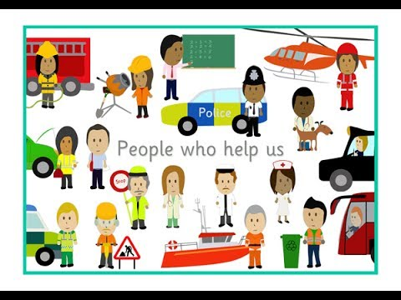
Key Questions in Class:
Can I explain how to keep safe around fire? (Firefighter/Bonfire night)

Can I explain how to take care of animals? (Vet)

Can I explore what is inside my body? (Doctors/Nurses)

Can I investigate how to keep safe around water? (Lifeguard/RNLI)

Can I explore the process of writing and posting a letter? (Postal workers)

Can I explore consequences of good and bad choices? (Police officer)

Learning all about people who help us – We will begin to think about What does it mean to help? Who are the people that help us? How and why do they help us? What is the same and what is different about these professions? As we find out about each different job, we will use subject specific language and identifying overlapping equipment such as ‘syringe’. In the context of different problems who would we go to? We will be having lots of circle times practicing our listening and speaking skills, as well as developing our confidence in the classroom which will be needed for when different visitors come to the classroom. We will be engaging in role play and discussing different scenarios such as ‘What would you do if you were lost in a supermarket?’

Retrieval – What should I already know? That there are different services within my world, perhaps I have seen a police car before, or heard the noise of a siren. That some people wear ‘uniforms’ to tells us what their job is.
Some things we will be learning…
We will be looking at different professions and how they help us in different scenarios. Some help us during ‘emergencies’ and others help us to ‘keep healthy’. We will be considering how we keep other people and animals safe and keeping our own bodies/teeth healthy. This will involve trying different foods and cooking. We will adapt known stories and begin to use our imagination to create our own ‘burglars’ for example.

Stories and songs- Head, shoulders, knees and toes, Funnybones song, Londons burning.
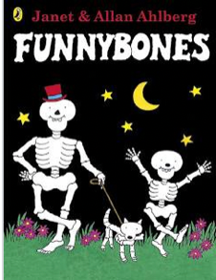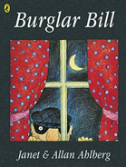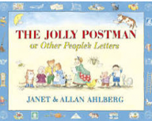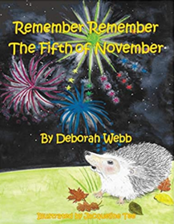

Understanding the World!
People Who Help Us
F2 Autumn 2 – KNOWLEDGE ORGANISER

