|  |  |
| --- | --- |
| Key Vocabulary and Facts | |
| Exercise | An activity to keep us healthy and active. |
| 5 Senses | Sight, see, hearing, hear, smell, taste, touch, feel. |
| Village | An area with a few houses that is smaller than a town. |
| Harvest | Gathering crops. |
| Sukkot | A Jewish festival of thanksgiving |

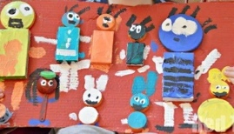

**Stories and songs-** Head, shoulders, knees and toes.

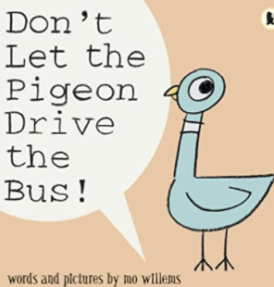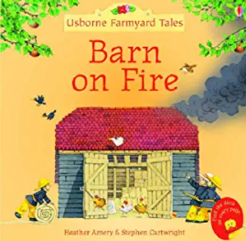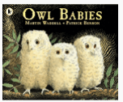

Learning all about me – Who are we? Who are our new friends? Who has brothers, who has sisters? What colour eyes do we have? What are our favourite foods? What about our parents and grandparents? Where do we live? We will suggest some rules for the classroom to keep us safe and happy as well as learning about routines in school, such as ‘fire drills’. We will be having lots of circle times as we do this, practising our listening and speaking skills, as well as developing our confidence in the classroom. As we find out about each other, we will see we have lots in common and the potential to play and learn with others who share the same interests. We will also be finding out about our bodies, learning about what keeps us healthy, as well as some of the parts of the body children might not know (e.g. shin or calf, which is the same name as a baby cow!).

**Some things we will be learning…**

5 senses are: sight, hearing, taste, touch, smell. Eye colours are blue, brown or green (or somewhere in-between!) Fruit and vegetables are healthy and we need to try to eat 5 portions a day. Families come in all shapes and sizes and celebrate their diversity. We will learn about family trees.

**Home learning Project**

Make a model/portrait of yourself or someone from your family.

Upload photos of your work to Tapestry.

Key Questions in Class:

Can I investigate my own features and what I look like?

Can I discuss things I like to do and what makes me special?

Can I explain what we do in my family and who is important to me?

Can I explore my immediate environment and where local food comes from?

Can I celebrate Harvest and other festivals such as Sukkot?

Can I explore features of Autumn and how it makes me feel?

**Understanding the World!**

Retrieval – What should I already know? That I come from a family made up of my parent(s)/carer(s) and any siblings. Beginning to explore and notice features about myself such as my hair colour, my eye colour e.t.c and how these may be different or the same as my peers.

All about me

**F2 Autumn 1 – KNOWLEDGE ORGANISER**