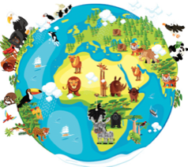 | Our world is a planet called Earth. It is important that we protect our planet and the animals that live on it with us.
Key Vocabulary and Facts
Extinct | A species (such as dinosaurs) that no longer has any living members.
Endangered | A species that is at risk of extinction.
Habitat | An animal’s (or plants) natural home.
Climate | The general weather within an area.
Diurnal | Animals active during the day.
Nocturnal | Animals active at night.
Hibernate | An animal that spends winter sleeping.
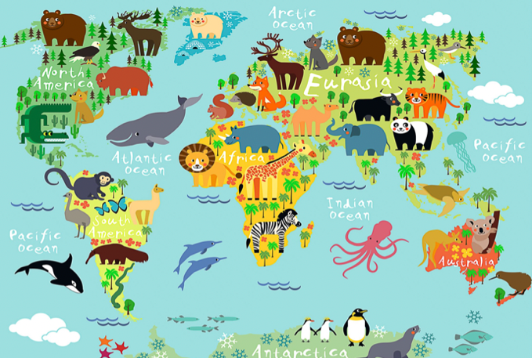
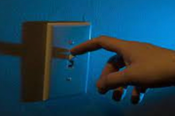
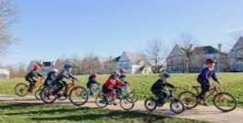
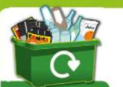
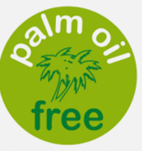
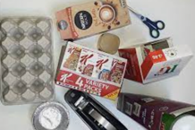
Understanding the world – We will be looking at the ‘world’ around us this term through our topic of amazing animals. We will be exploring species that are ‘extinct’ and questioning why and how this has happened? Then we will look at endangered or threatened animals and how we can look after our planet to protect their habitats and climate.
We will also have a focus on animals within our country by exploring both ‘nocturnal’ and ‘diurnal’ animals, before trying to spot some animals coming out of ‘hibernation’ when searching for signs of spring.

Animals across the years and how we can help protect the species we have left.
Amazing animals!
Key Questions:
Can I identify some extinct animals and explain why this may have happened?
Can I explore and name different ways I could help protect our planet?
Can I investigate the different climates and habitats of some animals?
Can I name some nocturnal and diurnal animals?
Can I name and recognise some signs of spring?

Learning about amazing animals –Sparks Imagination and Ignites Curiosity– It encourages children to generate questions for investigations. Understand that books can help us to research and deepen our knowledge (non-fiction). Thinking about ‘extinct’ and ‘endangered’ animals helps us challenge our ideas about what this means and encourages children to become more aware of our impact upon the planet we live on.

Help your child by teaching them the importance of looking after their planet.
Can you talk to them about their impact on the planet? Such as: Turning lights off…. Cycling to school… recycling… re-suing old items and turning them into something new….. buying palm oil free products….

F2 LEARNING – KNOWLEDGE ORGANISER

