|  |  |  |  |
| --- | --- | --- | --- |
| Key Vocabulary and Facts | | | |
| Seed |  | A small case that is shed by a plant and contains everything needed to grow a new plant |
| Roots |  | The part of a plant that is in the ground that absorbs water |
| Senses |  | Feel, see, hear, smell and taste |
| Kenya |  | Is a country in Africa |
| Beanstalk |  | The stem of a bean plant |

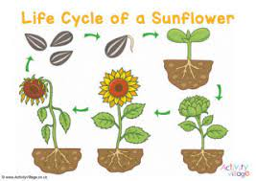

Key Questions and Lesson Foci:

Can I begin to explore changes that occur in Spring?

Can I attempt to provide a plant what it needs to grow?

Can I talk about our class stories?

Can I discuss parts of a sunflowers lifecycle?

Can I talk about some fruits from different countries?

Learning about growing – involves guiding children to make sense of their physical world. Children will be able to... observe changes in the season of spring. They will notice the growth and change of plants and the importance of caring for living things and their responsibility for taking care of the planet. Learning about growing inspires children by developing their natural inquisitiveness and curiosity about their living world.

Growing

**Our Wider World!**

Retrieval – What should I already know? There are different seasons throughout the year. During these seasons the natural environment changes such as trees and plants, along with the weather.

**F1 LEARNING – KNOWLEDGE ORGANISER**