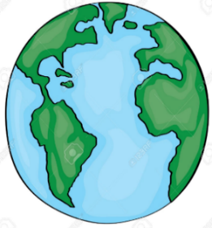 | -Our world is a planet called Earth. It is one of a number of planets that go around the Sun.  -This system of the Sun and planets is called the Solar System.
Key Vocabulary and Facts
Sun | A huge star that Earth and the other planets in our solar system orbit around.
Moon | A natural satellite which orbits Earth and other planets.
Crater | A large hole in the ground caused by an explosion or the impact of an asteroid.
Planet | A sphere object that orbits a star.
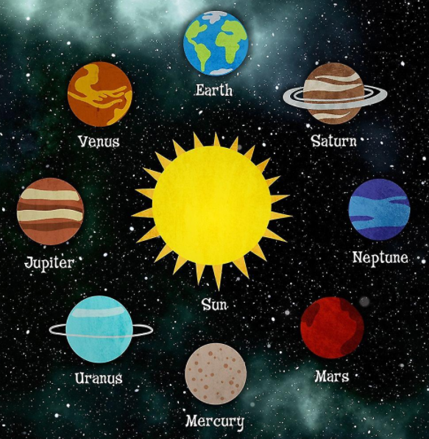
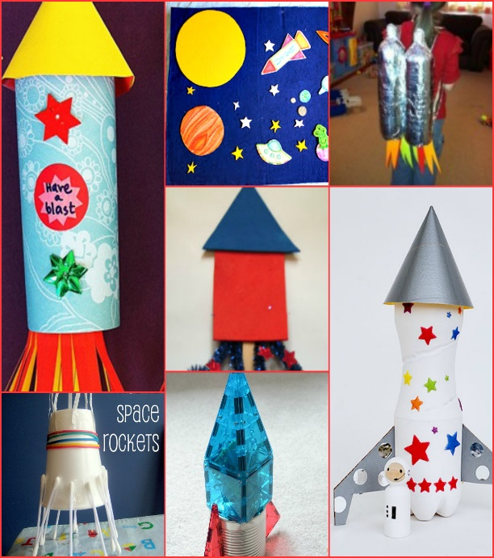
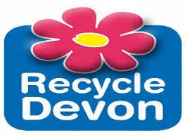
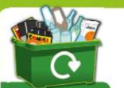
Key Questions:
Can I name the planet I live on?
Can I create my own planet and explain its different features?
Can I investigate what a star could be?
Can I make predictions on what a crater is?
Can I create my own Alien?

The 8 Planets in our solar system
SPACE
Learning about space –Sparks Imagination and Ignites Curiosity– It is all about the unknown, the 'what ifs?’ and the fascinating questions. It helps children become creative thinkers, to challenge current theories and to question. Aiming High– Learning about space is about inspiring the next generation of astronomers, and helping them to have high expectations of themselves and of their futures.

Help your child by teaching them the importance of looking after their planet.
Can you talk to them about recycling at home? Perhaps they can help you sort items to be recycled? Or maybe they can upcycle by bringing items into school for ‘junk’ modelling – For example, making a 3-D rocket?

F1 LEARNING – KNOWLEDGE ORGANISER

