|  |  |
| --- | --- |
| Key Vocabulary and Facts | |
| Lighthouse | a tower containing a light to warn or guide ships at sea. |
| Recycling | Recycling means taking a material and putting it through a process to be used again instead of being wasted. |
| Habitat | a natural environment that plants and animals live in. |
| Treasure | a quantity of precious metals, gems, or other valuable objects. |
| Ocean | the largest areas of water in the world. |
| Pollution | when the environment is contaminated, or dirtied, by waste, chemicals, and other harmful substances. |
| Rock-pool | a pool of water in a trench or rock left behind when the tide goes out. |

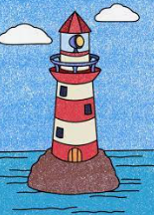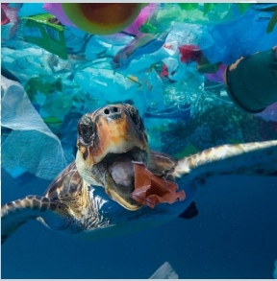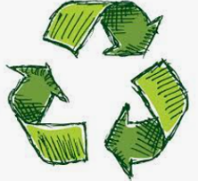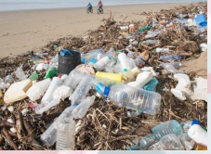

Key Questions and Lesson Foci:

Can I explain what can be found in the ocean?

Can I explore what can harm life under the sea?

Can I explain what we might see at the beach?

Can I explain how we stay safe near the sea?

Can I explain why a lighthouse is important?

Retrieval – What should I already know? There are Oceans on our planet that are home to lots of marine animals and plants such as ‘fish.... sharks... seaweed’.... On our beaches the Sea makes waves and lifeguards protect us when we are playing in the sea.

Humans can badly affect our planet and the animals that live on it. Litter, waste and a bad choice of materials can endanger lots of animals. For example, there are many different animals live in our oceans but our oceans have started to contain lots of our rubbish. This can make the sea animals poorly.

Learning about seaside – involves guiding children to make sense of their physical world. They will develop a sense of empathy towards nature and how to protect it. They will learn about the importance of caring for living things and their responsibility for taking care of the planet. Learning about the seaside encourages children to be ‘emergent marine biologists’ by developing their natural inquisitiveness and curiosity about their living world.

The Sea

**Our Wider World!**

**F2 LEARNING – KNOWLEDGE ORGANISER**