|  |  |
| --- | --- |
| Key Vocabulary and Facts | |
| Family | A group of children/child and parent(s)/Carer(s) living together. |
| Body | The parts that make up me. |
| Healthy | When you are not sick/ill. |
| Season | There are four in a year. |

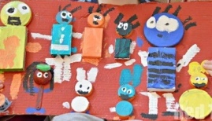

Learning all about me – We will begin to think about Who are we? Who are our new friends? Who has brothers, who has sisters? What colour eyes do we have? What are our favourite foods? What about our parents and grandparents? Where do we live?. We will be having lots of circle times practising our listening and speaking skills, as well as developing our confidence in the classroom. As we find out about each other, we will see we have lots in common and the potential to play and learn with others who share the same interests. We will also be finding out about our bodies, learning about and trying different fruit and vegetables, as well as beginning to explore different celebrations such as Harvest, Sukkot, and Halloween.

**Some things we will be learning…**

What I look like, such as my eyes and hair and identifying the different colours. Investigating and trying fruit and vegetables and understanding that these keep me healthy. That Families come in all shapes and sizes and celebrate their diversity.

**Stories and songs-** Head, shoulders, knees and toes.

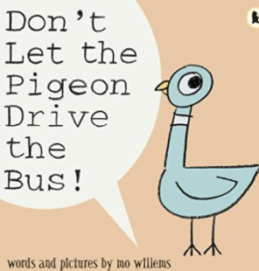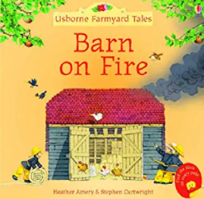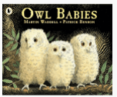

**Home learning Project**

Make a model/portrait of yourself or someone from your family.

Upload photos of your work to Tapestry.

Key Questions in Class:

Can I investigate what I look like?

Can I explore things I like to do and what makes me special?

Can I explain who I have in my family?

Can I explore the season of Autumn?

**Understanding the World!**

Retrieval – What should I already know? That I come from a family made up of my parent(s)/carer(s) and any siblings. Beginning to explore and notice features about myself such as my hair colour, my eye colour e.t.c and how these may be different or the same as my peers.

All about me

**F1 Autumn 1 – KNOWLEDGE ORGANISER**