Young children’s learning is often driven by their interests so plans need to be flexible (DfE, 2021). Therefore, these themes, ideas and texts may be adapted at various points to allow for children’s individual interests to flow through the provision within Class F.
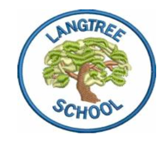 | Langtree Community Primary and Nursery School 2023-34
 | Autumn |  | Spring |  | Summer
 | Autumn 1 | Autumn 2 | Spring 1 | Spring 2 | Summer 1 | Summer 2
Class F Themes | All about me (ourselves) | People who help us  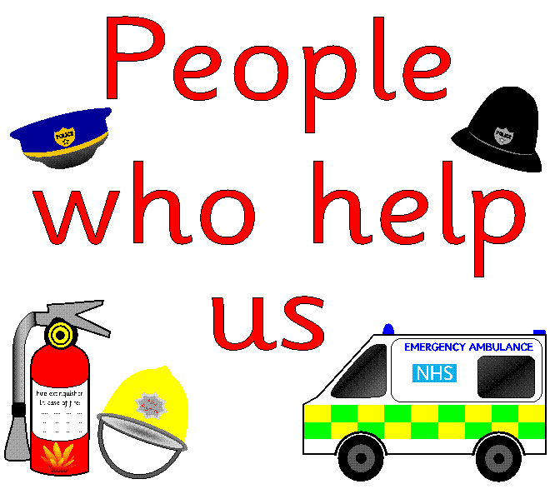 | Space  (on our travels) | Amazing Animals  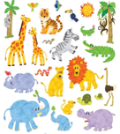 | Growing  (come  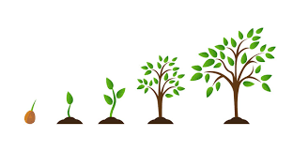  outside) | The Sea (under the sea/seaside)  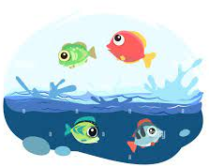
Some things we will be doing for Pupil Entitlement/  Enrichment: | Celebrations:  Talk from local farmer on harvest.  Harvest Assembly – showcasing art.  Local walk – discovering where our school is and features of our immediate environment.  Writing a letter to another school.  Religious festivals:  Sukkot. | Celebrations: Remembrance Day, Bonfire Night, Halloween, Black History Month.  Visits from ‘people who help us’ i.e. Police, Vet, Postal worker e.t.c  Religious festivals:  Diwali, Christmas. | Celebrations:  Chinese New year festival (creating our own food and celebrating together),  Burns night, Valentine’s day.  Story telling week – sharing a new book everyday.  Mental health week – activity each day.  Internet Safety Day – keeping safe online. | Celebrations:  Pancake day (making our own pancakes), Lent, Mother’s day, Red nose day.  World book day – sharing our favourite stories and dressing up.  Trip opportunities – Woolly Mammoth, Reptile visit, Trip to the Zoo.  R.E – Ramadan, Easter. How and why do we celebrate these? | Celebrations:  St George’s Day, Story telling month (children bring books from home), Deaf awareness day, Walk to School Week.  Share a story morning – inviting parents in  Trip opportunity to Rosemoor gardens. Visit from a local farmer.  RE - Eid | Celebrations:  Environment day, World Oceans Day, Recycling awareness, Father’s Day, Children’s Art Day.  Trip opportunities: Going to the aquarium, Going to the seaside. Visit from a beach lifeguard  Shared picnic – inviting parents in for our own picnic.  Leavers service and Sports Day.
Jigsaw | Being Me in My World | Celebrating Difference | Dreams and Goals | Healthy Me | Relationships | Changing Me
Some of the Key Texts we will use: | Me on the Map, All about families The Little Red Hen, Farmer Duck, Harvest Festival, I am the seed that grew the tree, | Ten Little Pumpkins. Remember remember the fifth of November, Funnybones, Mog and the V.E.T, Burglar Bill, Cops and Robbers, We’re going to the dentist, The jolly postman, The jolly Christmas Postman, Father Christmas, Dear Santa. | I like outer space, Look inside Space, Beegu, Whatever Next, The Smeds and the Smoos | Dinosaur bones, Harry and his bucketful of dinosaurs, Don’t disappear, There is a rangtan in my bedroom, Over and Under the Rainforest, Our Planet, Owl babies, Moon, What the Ladybird heard, We are going on an egg hunt. | Jasper’s Beanstalk, Handa’s Surprise, Jack and the Bean Stalk,  Eddie’s Garden, Mama Miti, Life Cycle of a Sunflower. | Rainbow fish, Lighthouse Keeper’s Lunch, Sharing a Shell, What the Ladybeard heard at the seaside, The Life cycle of a fish, Over and under the waves.
Resources/  Focus points | Class rules, On Entry Assessment – booklet  Safety sessions– sch rules & procedures, equip use; scissors, stapler, hole punch etc  Squiggle while you Wriggle, Dough Disco, Pen Disco,  Homes & Harvest - Safety  All About Me – focus on where we live, likes/dislikes, special people  Being Healthy– fruits & veg, Dr Role play  Harvest (to include Jewish celebration)  R.E – Sukkot - Jewish Soup & Bread making.  Autumn – sounds, changes, art | UK Culture-celebrations,  Bonfire / Firework Safety  Remembrance Sunday.  Why Poppies? Children in Need.  People that help us here in Langtree/ UK;  Doctor, vet, dentist, postman etc (visitors) Post Office - £, wrapping.  Christmas –  R.E –different celebrations/ Festivals–Diwalli, Christmas  Hanukkah  Jolly Postman/ Burglar Bill/  Create own stamps Christmas letter to family  Christmas Production | Make rockets, space station.  Exploring moon craters and how we could get to the moon.  Moon Dance Non-fiction books Darkness / Day & Night.  Looking at Constellations – creating our own  Festivals; Chinese New Year Valentine’s Day / putting others first (Kindness)  Valentines day – making cards.  Designing our own Aliens and then making them into biscuits. | Dinosaurs; exploring and creating our own museum. Becoming Palaeontologists!  Looking at different climates around the world and how animals have adapted to this in their habitats. Looking at non-fiction texts to make factfiles.  Creating our own fossils with salt dough, making binoculars.  Mother’s Day Cards Feely Boxes – with story  Spring Changes – walk, patterns,  Easter – creating cards including patterns and shapes (links to maths). | Planting our own seeds in the garden and bean’s in a bag – doing a ‘bean diary’. Using  Eddie’s Garden to learn How to Make Things Grow.  Trying different fruits, and making fruit salad with Handa’s surprise. Looking at this contrasted with Different fruits & veg (esp grown in UK)  Looking at traditional tales and making our own story.  Observe changes in the local countryside  Be proud of your colours! | Using the text Rainbow Fish – to talk about feelings & dance  to include colour wheel & colour walk.  Different sharks live in different places (Blue shark non-fiction) and creating a class book on sharks.  Looking at keeping safe in the sun- flags, Changes at the beach – tides, animals.  Investigating Seaside changes.  Father’s Day – Creating our own cards.  Lighthouse Keepers lunch – making our own picnic and inviting parents in.  Writing our own descriptive piece of what is ‘under the waves’.

