|  |  |
| --- | --- |
|  | Our world is a planet called Earth. It is important that we protect our planet and the animals that live on it with us. |

|  |  |
| --- | --- |
| Key Vocabulary and Facts | |
| Extinct | A species (such as dinosaurs) that no longer has any living members. |
| Endangered | A species that is at risk of extinction. |
| Habitat | An animal’s (or plants) natural home. |
| Nocturnal | Animals active at night. |
| Hibernate | An animal that spends winter sleeping. |

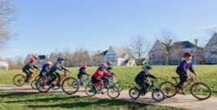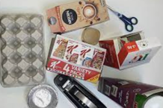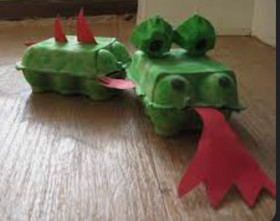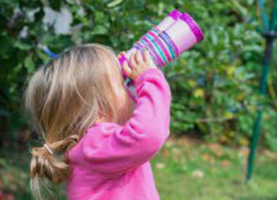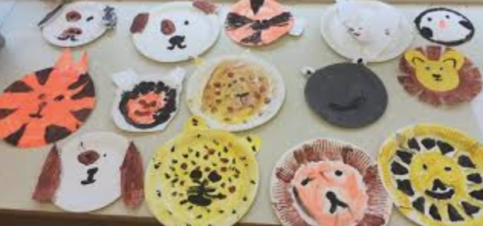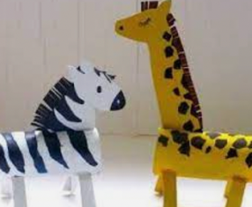

**Help your child by teaching them the importance of looking after their planet.**

Can you talk to them about their impact on the planet? Such as: Turning lights off…. Cycling to school… recycling… re-suing old items and turning them into something new….. buying palm oil free products….

Animals across the years and how we can help protect the species we have left

Amazing animals!

Key Questions:

Can I name some animals that are extinct?

Can I say some ways I can help to protect our planet?

Can I explore some animal’s natural habitats?

Can I identify some nocturnal animals?

Can I search for signs of spring?

Learning about amazing animals –Sparks Imagination and Ignites Curiosity– It encourages children to generate questions for investigations. Understand that books can help us to research and deepen our knowledge (non-fiction). Thinking about ‘extinct’ and ‘endangered’ animals helps us challenge our ideas about what this means and encourages **children to become more aware of our impact upon the planet we live on.**

**F1 LEARNING – KNOWLEDGE ORGANISER**