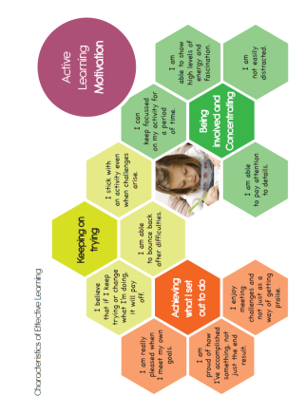

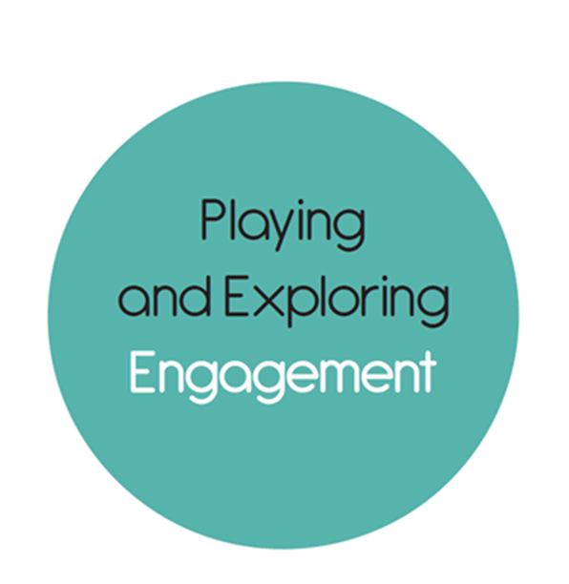

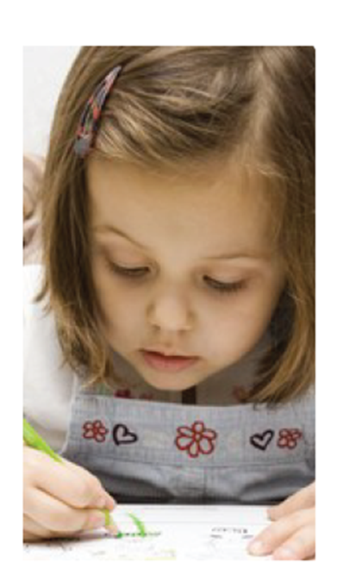

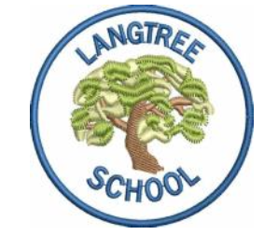
Langtree Community School
Characteristics of Effective Learning – A Parent’s Guide
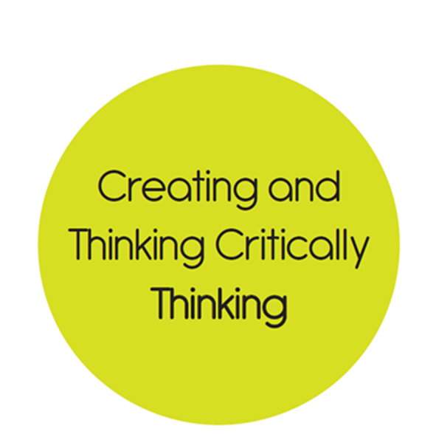


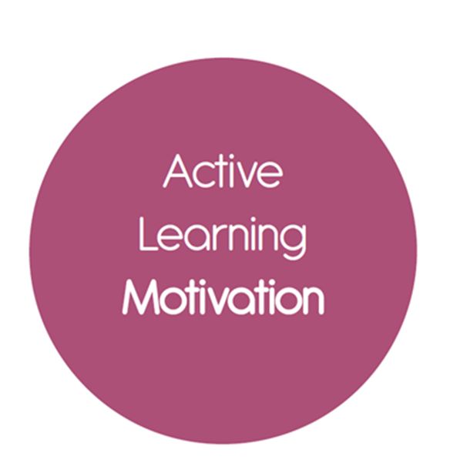
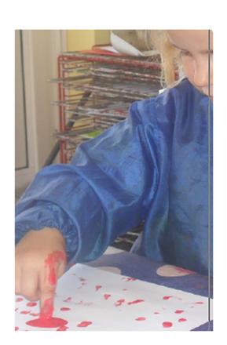

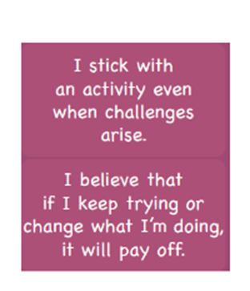
Dear Parents and Carers,

Characteristics of Effective Learning (CoEL)
A child’s individual learning characteristic will determine the way they respond to both the teaching and learning taking place in the environment. Three characteristics of effective teaching and learning identified by the EYFS are:
- playing and exploring - children investigate and experience things, and ‘have a go’;
- active learning - children concentrate and keep on trying if they encounter difficulties, and enjoy achievements; and
- creating and thinking critically - children have and develop their own ideas, make links between ideas, and develop strategies for doing things.
The focus of the CoEL is on how children learn rather than what they learn.
Underpinning the CoEL is the understanding that during their earliest years, children form attitudes about learning that will last a lifetime. Children who receive the right sort of support and encouragement during these years will be creative, and adventurous learners throughout their lives. The environment provided needs to nurture these CoELs without forgetting that children are individuals who bring their own needs, talents and histories.

This term we are focusing on Active Learning and our observations of your child may include a particular focus on this aspect of CoEL.
How can you help?
On the back of this guide is a
hexagonal image that looks at the
three main areas of Active Learning, namely, ‘Keep on trying’, ‘Being involved and concentrating’ and ‘Achieving what I set out to do’ with some statements in child speak to help understanding. For example, help your child to become aware of their own goals by supporting them to make plans. Describe what you see them trying to do, and encourage children to talk about their own processes and successes. Be specific when you praise, especially noting effort, such as how the child concentrates, tries different approaches, persists, solves problems, and has new ideas. Note when your child becomes deeply involved when you provide something that is new and unusual for them to explore.

Any ‘WOW’ moments you see we would greatly appreciate if you could please put these on Tapestry so we can have a snapshot of your child’s Active Learning at home too!

Please also use the ‘playing and exploring’ from last term to support these WOW observations and next term we will focus on Creating and Thinking Critically. All your contributions help us a build a picture of your unique child. Thank you for your support. ☺

