Aims: The Early Years Foundation Stage (EYFS) sets the standards that all early years providers must meet to ensure that children learn and develop well and are kept healthy and safe. It promotes teaching and learning to ensure children’s ‘school readiness’ and gives children the broad range of knowledge and skills that provide the right foundation for good future progress through school and life.
Goals: have been taken from the Department for Education, Development Matters Document 3-4 year old (2021).
Progression of Communication and Language
Skill | Autumn 1 | Autumn 2 | Spring 1 | Spring 2 | Summer 1 | Summer 2 | 3-4 yr old Goal
Listening, Attention and Understanding  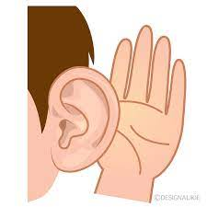 | To focus for a while although can be easily distracted.  To concentrate intently on an activity of their own choosing for a short period.  To engage in pretend play. | To understand and act on longer sentences.  To listen to a simple story with the help of pictures | To understand simple sentences.  To respond to instructions with more elements, e.g., “Pick up the blocks and put them in the box.” | To understand simple questions: who, what, where but generally not why.  To pay attention although may find it difficult to pay attention to more than one thing at a time. | To know lots of stories.  To enjoy longer stories and can remember much of what happens. | To retell a longer story.  To listen to others 1-2-1 or small groups when the conversation interests them.  To show an understanding of prepositions such as under, on top or behind. | Enjoy listening to longer stories and can remember much of what happens.  Pay attention to more than one thing at a time, which can be difficult.  Understand a question or instruction that has two parts, such as: “Get your coat and wait at the door”. Understand ‘why’ questions, like: “Why do you think the caterpillar got so fat?”
Speaking  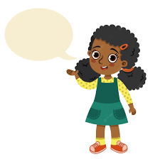 | To try speaking to an adult although may become frustrated when they cannot make themselves understood.  To start to say how they feel using simple words and actions/gestures  . | To talk but may just flit from topic to topic  To use speech sounds p, b, m, w but may still be learning to pronounce l, r  w, y, f, th and have difficulty with words like ‘banana’. | To try and use the correct tense although may muddle them up, e.g., “I bringed a bag.  To start a conversation. | To join in with repeated refrains in rhymes and stories.  To use a wider range of words. | To talk about familiar books and is able to tell a long story.  To sing a lot of songs. | To use the ‘why’ question.  To use longer sentences of 4-6 words.  To express their point of view.  To use words to problem-solve and organise their thoughts. | Use a wider range of vocabulary.  Sing a large repertoire of songs. Know many rhymes, be able to talk about familiar books, and be able to tell a long story.  Develop their communication but may continue to have problems with irregular tenses and plurals, such as ‘runned’ for ‘ran’, ‘swimmed’ for ‘swam’. Develop their pronunciation but may have problems saying: • some sounds: r, j, th, ch, and sh • multi-syllabic words such as ‘pterodactyl’, ‘planetarium’ or ‘hippopotamus’.  Use longer sentences of four to six words.  Be able to express a point of view and to debate when they disagree with an adult or a friend, using words as well as actions. Start a conversation with an adult or a friend and continue it for many turns. Use talk to organise themselves and their play: “Let’s go on a bus... you sit there... I’ll be the driver.”
Progression of Personal, Social and Emotional Development
Skill | Autumn 1 | Autumn 2 | Spring 1 | Spring 2 | Summer 1 | Summer 2 | 3-4 yr old Goal
Self-Regulation  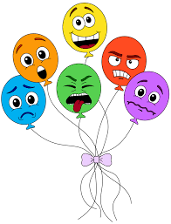 | To begin to self-regulate during transition times but may struggle.  To begin to have a sense of who they are. | To find ways to calm themselves and/or be calmed by a familiar adult.  To begin to show ‘effortful control’, beginning to wait rather than grab.  To express a range of emotions | To begin to sort out minor conflicts  and begin to accept that not everyone  can be chosen. | To talk about how they feel.  To begin to understand how others are feeling.  To begin to explore a range of emotions. | To begin to solve conflicts. | To talk about their feelings using vocabulary such as ‘happy’, ‘sad’, ‘angry’ or ‘worried’. | Develop their sense of responsibility and membership of a community.  Find solutions to conflicts and rivalries. For example, accepting that not everyone can be Spider-Man in the game, and suggesting other ideas.  Develop appropriate ways of being assertive. Talk with others to solve conflicts. Talk about their feelings using words like ‘happy’, ‘sad’, ‘angry’ or ‘worried’.  Understand gradually how others might be feeling.
Managing Self | To play with increasing confidence.  To grow in independence – “Me do it.” | To have high levels of wellbeing and involvement.  To use the toilet with support and increasing independence. | To self-select activities and seek help if necessary. | To be increasingly able to follow rules and not always need to be reminded of the rules by an adult. | To begin to understand the importance of healthy food choices.  To wash and dry their hands with increasing independence. | To begin to show a ‘can do’ attitude.  To select resources that help them achieve their own goal | Select and use activities and resources, with help when needed. This helps them to achieve a goal they have chosen, or one which is suggested to them.  Increasingly follow rules, understanding why they are important. Remember rules without needing an adult to remind them.  Be increasingly independent in meeting their own care needs, e.g., brushing teeth, using the toilet, washing and drying their hands thoroughly. Make healthy choices about food, drink, activity and toothbrushing.
Building Relationships  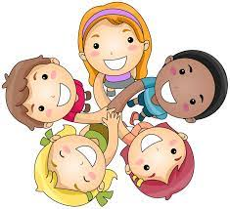 | To enjoy playing alone, alongside and with others.  To engage through gesture and gaze | To notice and ask about difference, e.g., skin colour.  To begin to develop friendships with others. | To invite others to play and attempt to join in others’ play.  To begin to see themselves as part of a community and have a developing sense of responsibility, e.g., at tidy up time. | To be more confident in social situations.  To seek out companionship with adults and other children. | To become more confident and outgoing with unfamiliar situations and changes in routine. | To play with one other or more children, extending and elaborating ideas. | Become more outgoing with unfamiliar people, in the safe context of their setting.  Show more confidence in new social situations.  Play with one or more other children, extending and elaborating play ideas.
Progression of Physical Development
Skill | Autumn 1 | Autumn 2 | Spring 1 | Spring 2 | Summer 1 | Summer 2 | 3-4 yr old Goal
Gross Motor Skills | To independently use a range of appropriate resources (crawl in tunnels, use Lego etc).  To sit on push-along toys, scooters and trikes. and materials. | To run, jump, climb and begin to use stairs independently.  To develop their manipulation and control, exploring different tools and materials. | To know that their playing is developing their body,  To begin to throw and release objects overarm.  To participate in finger and action rhymes.  To roll, crawl, jump and run.  To self-select things that they want to use.  To work with others, e.g., to move a big box.  To create lines and circles, pivoting from the shoulder and elbow  To have explored Dough Gym to include low-load control. shoulder, | To want to be increasingly independent, e.g. dressing and undressing.  To use large and small motor skills to do things independently - zips, buttons, pour drinks etc.  To walk a greater distance.  To use large movements, e.g. with ribbons.  To work with others, e.g., to move a big box.  To develop their shoulder, elbow and wrist pivot. | To develop their movements to balance, ride and use balls.  To climb using alternate feet, including climbing stairs.  To balance on one leg, momentarily.  To increasingly remember a sequence of movements related to rhythm and rhyme.  To understand how to use equipment safely. | To develop their proprioception and control of their body - body movements, use of space and fundamental movement abilities.  To develop their hand/eye coordination.  To hop, skip and climb.  To begin to work in a team or group.  To grasp and release with two hands to throw and catch a large ball.  To comfortably hold a pencil, pen or paintbrush. | Continue to develop their movement, balancing, riding (scooters, trikes and bikes) and ball skills. Go up steps and stairs, or climb up apparatus, using alternate feet. Skip, hop, stand on one leg and hold a pose for a game like musical statues. Use large-muscle movements to wave flags and streamers, paint and make marks.  Start taking part in some group activities which they make up for themselves, or in teams. Increasingly be able to use and remember sequences and patterns of movements which are related to music and rhythm.  Match their developing physical skills to tasks and activities in the setting. For example, they decide whether to crawl, walk or run across a plank, depending on its length and width.  Choose the right resources to carry out their own plan. For example, choosing a spade to enlarge a small hole they dug with a trowel. Collaborate with others to manage large items, such as moving a long plank safely, carrying large hollow blocks.
Fine Motor Skills  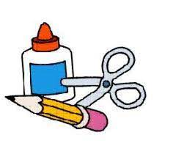 | To develop their manipulation and control, exploring different tools and materials.  To maybe pick up objects with a Palmer Grip.  To sit comfortably and hold scissors in their preferred hand.  To open and close the scissors smoothly with no paper to cut. | To develop their manipulation and control, exploring different tools and materials.  To maybe pick up objects with a Palmer Grip.  To sit comfortably and hold scissors in their preferred hand.  To open and close the scissors smoothly with no paper to cut. | To use large motor skills to do things independently.  To point with their first finger, sharing their attention with an adult.  .  To self-select things that they want to use.  To show the `thumb up’ of holding scissors.  To experiment with mark making and emergent writing | To use small motor skills to do things independently - zips, buttons, pour drinks etc.  To participate in finger and action rhymes.  To use one-handed tools and equipment - snipping with scissors with support.  To make one simple snip on a piece of paper, initially with support and then independently.  . | To understand how to use equipment safely.  To use one-handed tools and equipment - snipping with scissors independently.  To hold the paper when cutting with their non-dominant hand to help and hold the paper that they are cutting.  To have a dominant hand. | To hold mark making tools with thumb and all fingers.  To hold the paper when cutting with their non-dominant hand to help and hold the paper that they are cutting.  To cut a straight and curved line.  To cut a circle, square and complex shape.  To arch their palm; have in-hand manipulation fluidity; use thumbs in opposition and have finger isolation.  dominant | Use one-handed tools and equipment, for example, making snips in paper with scissors. Use a comfortable grip with good control when holding pens and pencils. Show a preference for a dominant hand.  Be increasingly independent as they get dressed and undressed, for example, putting coats on and doing up zips.
Progression of Literacy
Skill | Autumn 1 | Autumn 2 | Spring 1 | Spring 2 | Summer 1 | Summer 2 | 3-4 yr old Goal
Comprehension  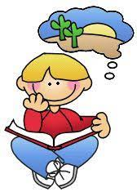 | To enjoy sharing books with adults.  To repeat words and phrases.  To touch and handle books.  To notice pictures and begin to recognise what they stand for. | To ask questions about simple stories.  To touch and handle digital devices.  To notice symbols and begin to recognise what they stand for. | To have favourite stories they love to share.  To handle a book carefully.  To talk about stories. | To react and respond to illustrations, characters and narratives through sharing books, using questions and imaginative play.  To maybe engage with print around them - digital and media texts. | To use their memory of story to retell and recount what they have seen and heard.  To be increasingly familiar with a when they work with memorable texts.  To become an oral storyteller and re-enact a text. | To use their memory of story to perform, interpret and invent based on what they have seen and heard.  To increasingly predict when they work with memorable texts.  • To develop a growing awareness of what is involved for being able to read themselves. | Understand the five key concepts about print: • print has meaning • print can have different purposes • we read English text from left to right and from top to bottom • the names of the different parts of a book • page sequencing.  Engage in extended conversations about stories, learning new vocabulary.
Word Reading  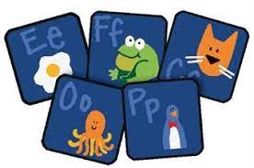 | To develop their listening skills and awareness of sounds in the environment. | To experience and develop their awareness of sounds made with instruments and noise makers | To develop awareness of sounds and rhythms | To experience and appreciate rhythm and rhyme and to develop awareness of rhythm and rhyme in speech | To develop understanding of alliteration | To distinguish between the differences in vocal sounds, including oral blending and segmenting.  To develop oral blending and segmenting of sounds in words | Develop their phonological awareness, so that they can: • spot and suggest rhymes • count or clap syllables in a word • recognise words with the same initial sound, such as money and mother
Writing | To make marks to be their name.  To enjoy the sensory experience of making marks.  To enjoy drawing and writing on paper and in different textures, e.g., sand or shaving foam.  To copy movements. | To add meaning to marks they make.  To distinguish between the marks that they make. • To enjoy drawing and writing on screen.  To enjoy free drawing. | To imitate adults’ writing by making continuous lines circles or shapes.  • To begin to make shapes to represent the initial sound of their name. | To identify the initial letter of their name.  To begin to make letter type shapes to represent the initial sound of their name without support. | To write some letters in their name.  To show an interest in words and illustrations in the environment.  To show an interest in letters on a keyboard and begin to make letter type shapes to represent the initial sound of their name and other familiar words.. | To write some of or their entire name.  To write some letters accurately.  To begin to navigate apps and websites on digital media using drop down menus. | .Use some of their print and letter knowledge in their early writing. For example: writing a pretend shopping list that starts at the top of the page; writing ‘m’ for mummy. Write some or all of their name.  Write some letters accurately.
Progression of Mathematics
Skill | Autumn 1 | Autumn 2 | Spring 1 | Spring 2 | Summer 1 | Summer 2 | 3-4 yr old Goal
Number  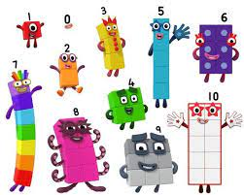  Focus – links to long-term plan are in blue. | To take part in finger number rhymes.  To show counting like behaviour.  To notice numbers around them, both inside and out.  To develop an awareness of numbers through rhymes and in their surroundings. | To combine objects.  To react to changes in a group up to 3.  There are more ______ than ______ / there are fewer _____ than ______  To point or touch each item, saying one number for each item, using the stable order 1, 2, 3, 4, 5.  To count in everyday contexts but may miss out or muddle number sequences.  To maybe enjoy counting verbally as far as they can go. | To explore and understand numbers 1, 2 and 3.  To begin to count on their fingers.  To use some number names in play and be fascinated with big numbers.  To recite numbers beyond 5.  To give 2 or 3 objects from a group.  To have fast recognition of up to 3 objects. | To explore and understand numbers 4, 5 and 6.  To subitise to 3 with no need to count them.  To begin to recognise numerals 0-10.  To show finger numbers to 5.  To link numerals and amounts, e.g., show 4 fingers.  To solve everyday problems to 5.  To begin to understand that each counting number is one more than the one before. | To experiment with their own marks for numbers.  To begin to use their understanding of numbers to solve everyday problems - in play and meaningful activities. | To compare groups of up to 5 objects.  To know the `cardinal principle’ - the last number reached when counting tells them how many there are in total.  To begin to know that a bigger number can be created out of smaller numbers.  To separate a group of objects in different ways and know that the total is still the same.  To understand the `order relevance’ principle that the order they count the objects in is irrelevant; there will still be the same number. | Develop fast recognition of up to 3 objects, without having to count them individually (‘subitising’). Recite numbers past 5. Say one number for each item in order: 1,2,3,4,5. Know that the last number reached when counting a small set of objects tells you how many there are in total (‘cardinal principle’). Show ‘finger numbers’ up to 5. Link numerals and amounts: for example, showing the right number of objects to match the numeral, up to 5.  Experiment with their own symbols and marks as well as numerals. Solve real world mathematical problems with numbers up to 5.
Patterns and  Numerical Patterns  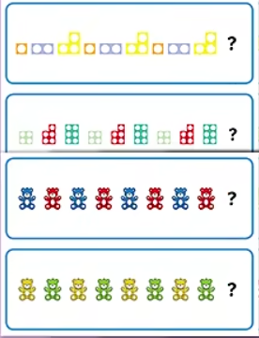  Focus – links to long-term plan are in blue. | To note patterns such as A,B.  To be able to sort objects according to colour, shape and size | To show an interest in patterns, songs and rhymes. | To talk about patterns around them.  To join in with simple patterns in rhymes, games, dances, and stories. | To begin to predict what might happen in a predictable situation.  To join in with simple patterns in rhymes, games, dances, stories and predict what may come next. | To notice and correct an error in a simple pattern.  To explore repeating patterns in everyday objects. | To extend a simple ABABAB pattern. | Compare quantities using language: ‘more than’, ‘fewer than’.  Talk about and identify the patterns around them. For example: stripes on clothes, designs on rugs and wallpaper. Use informal language like ‘pointy’, ‘spotty’, ‘blobs’, etc. Extend and create ABAB patterns – stick, leaf, stick, leaf. Notice and correct an error in a repeating pattern. Begin to describe a sequence of events, real or fictional, using words such as ‘first’, ‘then...’
Shape, Space and Measure  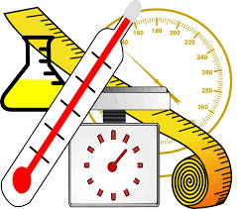  Focus – links to long-term plan are in blue. | To name at least 2 colours  To have some spatial awareness, e.g., climbing into a space.  To enjoy exploring spaces around them.  To use their body to explore spaces.  To begin to know their way around familiar environments.  . | To begin to compare objects and use stem sentence  The ______ is smaller /larger than the _____. (bigger, smaller, full, empty, taller, shorter).  To begin to put objects inside each other.  To explore shapes around them in their play.  To choose puzzle pieces and try to fit them in.  To make simple constructions. | To respond to spatial and positional language.  To explore different shapes and sizes.  To attempt to make arches and enclosures in their play with construction sets.  To begin to anticipate times of the day.  To use items based on their shape for use in their play.  To select appropriate shapes for building. | To explore how things look from different views, points, near and far.  To recognise when two shapes are the same. • To compare sizes.  To compare amounts and use words like ‘lots’ and ‘more’.  To explore the difference in weight, length, size and capacity.  To respond to common shape names. | To show an awareness of shape similarities and differences in objects.  To combine shapes in play.  To begin to describe a sequence of events, real or fictional using words like first… next… etc.  To recall the sequence of events in everyday life and stories.  To enjoy partitioning and combining 2D and 3D shapes, making new shapes.  To talk about and explore 2D and 3D shapes, talk about their names and some properties. | To describe a familiar route.  To respond to and use the language of direction.  To use words like ‘in front of’ and ‘behind’.  To use position.  To use words like ‘in front of’ and ‘behind’.  To find longer, shorter, heavier, lighter, more/less full of items in meaningful experiences.  To compare quantities and use language like ‘more than’.  To compare objects, size, length, weight and capacity. | Talk about and explore 2D and 3D shapes (for example, circles, rectangles, triangles and cuboids) using informal and mathematical language: ‘sides’, ‘corners’; ‘straight’, ‘flat’, ‘round’.  Understand position through words alone – for example, “The bag is under the table,” – with no pointing. Describe a familiar route. Discuss routes and locations, using words like ‘in front of’ and ‘behind’.  Make comparisons between objects relating to size, length, weight and capacity.  Select shapes appropriately: flat surfaces for building, a triangular prism for a roof, etc. Combine shapes to make new ones – an arch, a bigger triangle, etc.
Progression of Understanding the World
Skill | Autumn 1 | Autumn 2 | Spring 1 | Spring 2 | Summer 1 | Summer 2 | 3-4 yr old Goal
Past and Present  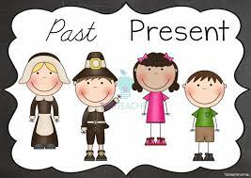 | To enjoy playing with small world, building on their first-hand experiences. | To begin to make sense of their own life-story. | To begin to make sense of their own family history. | To begin to make sense of where they live. | To know there are different countries in the world.  To comment and ask questions about their world such as the place where they live | To comment and ask questions about their world.  To talk about the differences they have experienced in their world or from what they have seen in photos. | Begin to make sense of their own life-story and family’s history.
People, Culture and Communities | To make connections between the features of their family and other families.  To enjoy looking at photographs of themselves and other familiar people.  To begin to make their own friends. | To make connections between the features of their family and other families.  To be curious and show an interest in stories about people or animals. | In pretend play, to imitate everyday actions and events from their own family and cultural background. | In pretend play, to imitate everyday actions and events from their own family and cultural background. | To be interested in different occupations.  To know there are different countries in the world and talk about the differences they have experienced or seen in photos. | To continue to develop a positive attitude about the differences between people  To comment and ask questions about their world such as the place where they live.  . | Show interest in different occupations.  Continue developing positive attitudes about the differences between people.  Know that there are different countries in the world and talk about the differences they have experienced or seen in photos.
The Natural World  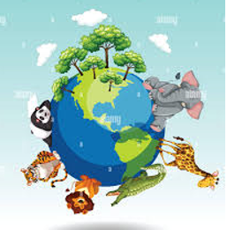 | To explore and respond to their environment, natural phenomena and natural materials. | To use their senses.  To explore materials. • | To talk about what they see using a wide vocabulary.  To know that things can be used in different ways. | To talk about some of the things they have observed such as plants, animals and natural objects. | To explore how things work.  To begin to understand the need to respect and care for the world. | To plant and care for seeds and plants.  To understand the life-cycle of a plant and animal. •  To explore and talk and about different forces they can feel. | Use all their senses in hands-on exploration of natural materials. Explore collections of materials with similar and/or different properties. Talk about what they see, using a wide vocabulary.  Plant seeds and care for growing plants. Understand the key features of the life cycle of a plant and an animal. Begin to understand the need to respect and care for the natural environment and all living things.  Explore and talk about different forces they can feel.  Talk about the differences between materials and changes they notice.
Technology  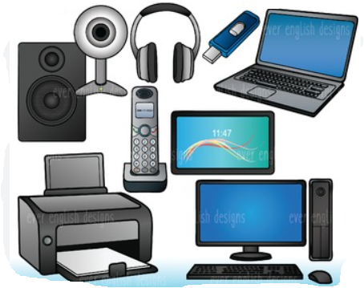 | To press buttons on moveable toys. | To explore Technology in the room. | To show an interest in technology (IWB). | To explore equipment such as a lightbox. | To talk about Technology they use at school. | To explore BeeBots and program them to move.  To talk about technology they use at home. | Explore how things work.
Progression of Expressive Arts and Design
Skill | Autumn 1 | Autumn 2 | Spring 1 | Spring 2 | Summer 1 | Summer 2 | 3-4 yr old Goal
Creating with Materials  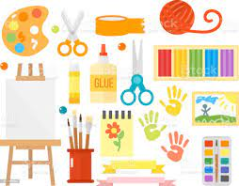 | To start to make marks intentionally. •  To engage in pretend play. •  To explore colours.  To create using small world and construction. | To maybe give meaning to the marks they make.  To show a range of emotions in their drawings. | To use their senses to explore different materials.  To explore colours.  To take part in pretend play.  To create using small world and construction. | To join materials and explore textures.  To show a range of emotions in their drawings.  To explore colours and colour mixing.  To respond to their senses. | To begin to develop stories using small world and equipment.  To freely explore different materials and think about how they may use them.  To use their drawings to represent ideas like movements and loud noises.  To respond to their senses. | To explore using 2D and 3D structures.  To develop their own ideas.  To create closed shapes with continuous lines.  To draw with increasing complexity and detail.  To use their drawings to represent ideas like movements and loud noises. | Take part in simple pretend play, using an object to represent something else even though they are not similar. Begin to develop complex stories using small world equipment like animal sets, dolls and dolls houses, etc. Make imaginative and complex ‘small worlds’ with blocks and construction kits, such as a city with different buildings and a park.  Explore different materials freely, to develop their ideas about how to use them and what to make. Develop their own ideas and then decide which materials to use to express them. Join different materials and explore different textures.  Create closed shapes with continuous lines and begin to use these shapes to represent objects. Draw with increasing complexity and detail, such as representing a face with a circle and including details. Use drawing to represent ideas like movement or loud noises. Show different emotions in their drawings and paintings, like happiness, sadness, fear, etc. Explore colour and colour mixing. Show different emotions in their drawings – happiness, sadness, fear, etc.
Being Imaginative and Expressive | To move and dance to music.  To explore their voice.  To explore different sound makers.  To enjoy songs and rhymes  To enjoy taking part in action songs. | To respond emotionally and physically to music.  To create sound effects and movements, e.g., the sound of a car.  To use words to describe sounds and music. | To make rhythmical and repetitive sounds.  To listen with increased attention to sounds.  To enjoy songs and rhymes. | To move, sing and listen whilst playing instruments.  To explore different sound makers. | To sing loudly.  To ‘pitch match’.  To create sounds, movements and drawings to accompany stories. | To maybe create their own songs.  To play a range of instruments with increasing control, expressing their ideas and feelings/emotions.  To create sounds, movements and drawings to accompany stories. | Listen with increased attention to sounds. Respond to what they have heard, expressing their thoughts and feelings.  Remember and sing entire songs. Sing the pitch of a tone sung by another person (‘pitch match’). Sing the melodic shape (moving melody, such as up and down, down and up) of familiar songs. Create their own songs or improvise a song around one they know.  Play instruments with increasing control to express their feelings and ideas.

